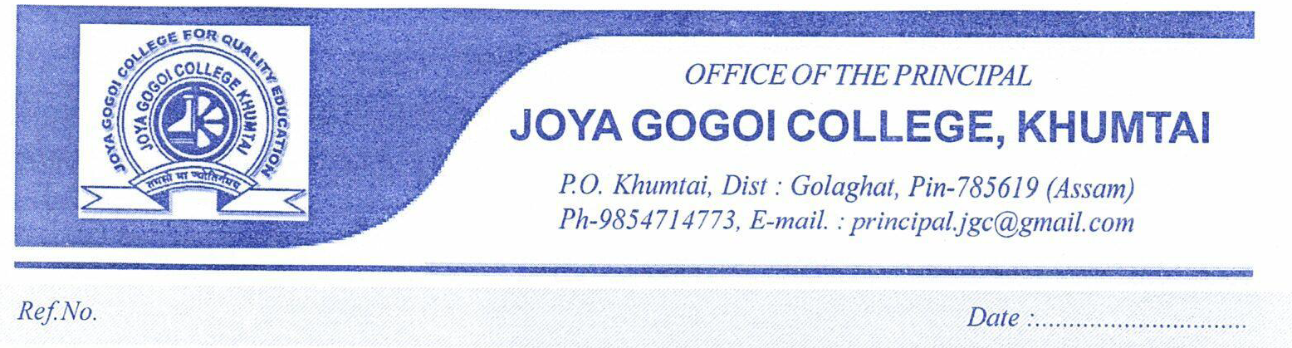

This is hereby declared that following list includes the extension activities are carried out in the last five academic session (2018-19 to 2022-23).

|  |  |  |  |  |
| --- | --- | --- | --- | --- |
| **Sl No** | **Name of the activity** | Organized by | Venue | Date |
| 1 | New Indian Literacy Programme | IQAC, Joya Gogoi College | Leteku Chapori L P School, Khumtai | **28/11/2023** |
| 2 | Celebration of National Science Day | Chemistry Department, Joya Gogoi College | Golok Borbora High School | 28/02/2023 |
| 3 | Celebration World Story telling Day -2023 | Assamese & English Department, Joya Gogoi College | 1.N0 Khumtai Model L.P.School | 20/03/2023 |
| 4 | One day free eye check up camp | IQAC, Joya Gogoi College and Alumni Association in collaboration with Sight Plus, Jorhat | Swahid Kamal Miri High School, Baulipara | 21/05/2023 |
| 5 | Celebration of World Cultural Diversity day | IQAC, Joya Gogoi College in collaboration with English Department | Gulung Temera | 21/05/2023 |
| 6 | One day free eye check up camp | Joya Gogoi College in collaboration with Sight Plus, Jorhat | Balya Bikash Bhawan, Khumtai | 14/05/2023 |
| 7 | Children’s Day Celebration | IQAC, Joya Gogoi College in collaboration with Education Department | 1.N0 Khumtai Model L.P.School | 14/11/2023 |
| 8 | Free Training Camp for Examination of 3rd & 4th Grade under Government of Assam | Joya Gogoi College Teachers’ Unit in association with College Alumni Association | Joya Gogoi college | 9/07/2022 to 24/07/2022 |
| 9 | Awareness programme on Blindness | English Department, Joya Gogoi College in collaboration with Rangamati Kaibarta Gaon Panchayat | Rangamati Kaibarta Gaon Panchayat | 07/04/2022 |
| 10 | Awareness Programme on women Education | IQAC of Joya Gogoi College in collaboration with Khumtai Hakimbasti Tea Tribe community | Khumtai Hakimbasti | 3/04/ 2022 |
| 11 | Awareness programme on Covid-19 Pandemic situation | Teachers’ Unit of Joya Gogoi College | Public places in Khumtai Locality | 17th March to 31st March, 2020 |
| 12 | Celebration of International Women Day | IQAC of Joya Gogoi College in collaboration with Teachers’ Unit Joya Gogoi college,Khumtai | Madhya Khumtai Primary School, Khumtai | 8/03/2019 |
| 13 | Awareness Programme on "Child Marriage is a Social Malady: Prohibition and Remedies" | IQAC, Joya Gogoi College in collaboration with Khumtai Bagan Balya Vikash Bhawan. | Bagan Club Ghor | 08-10-2023 |
| 14 | One day Training Programme on Embroidery, Cutting and Tailoring | IQAC, Joya Gogoi College in collaboration with Gonakpukhuri High School, Gonakpukhuri. | Gonakpukhuri High School | 05-02-2024 |
| 15 | Two days Training Programme on Embroidery, Cutting and Tailoring | IQAC, Joya Gogoi College in collaboration with Apiram Gogoi High School | Apiram Gogoi High School | 02-02-2024 to  03-02-2024 |
| 16 | Observation of National Science Day at nearby Golok Borbora High School among school students through chemistry magic organized b | Department of Chemistry in association with IQAC, Joya Gogoi College. | Golok Borbora High School | 28-02-2023 |
| 17 | A series of lectures by the Students and Science faculty members in six different lower primary schools of Khumtai locality to popularize basic sciences among the school students. | Science faculty in association with IQAC, Joya Gogoi College and Student Union | 1 No. Khumtai Model School,  Madhya Khumtai LP School,  Leteku Chapori LP School  2 No Butalikhuwa LP School | 21-06-2023 to 24-06-2023 |
| 18 | Departmental survey on “Socio economic condition of Schedule Caste Community of Rangamati Koiborta Gaon,Rangamati” of Golaghat district | Education Department | Koiborta Gaon,Rangamati | 14/03/2023 |
| 19 | Distribution of Farmers Friendly Agricultural Hand Tools | Department of Engineering, AAU, Jorhat in collaboration with Department of Education, Joya Gogoi College, Khumtai | Office of the Gram Pradhan, Rangamati Kaibarta Gaon, Rangamati | 30-03-2023 |
| 20 | Bihu Exhibition cum Sale on Local Products. | Department of Education, Joya Gogoi College, Khumtai | Joya Gogoi College premise | 12/04/2023 |
| 21 | Educational Awareness Camp on "NEP 2020 in School Level: Prospects and Challenges". | IQAC, Joya Gogoi College, Khumtai in Collaboration with Apiram Gogoi High School, Bholaguri | Apiram Gogoi High School, Bholaguri | 07-05-2022 |
| 22 | Educational Awareness Camp on "NEP 2020 in School Level: Prospects and Challenges". | IQAC, Joya Gogoi College, Khumtai in Collaboration with Melamora High School | Melamora High School | 07-04-2022 |
| 23 | Educational Awareness Camp on "NEP 2020 in School Level: Prospects and Challenges". | IQAC, Joya Gogoi College in Collaboration with Khumtai Higher Secondary School, Khumtai | Khumtai Higher Secondary School | 23-04-2022 |
| 24 | Educational Awareness Camp on "NEP 2020 in School Level: Prospects and Challenges". | IQAC, Joya Gogoi College in collaboration with Bholaguri KMHS School | Bholaguri KMHS School | 05-04-2022 |